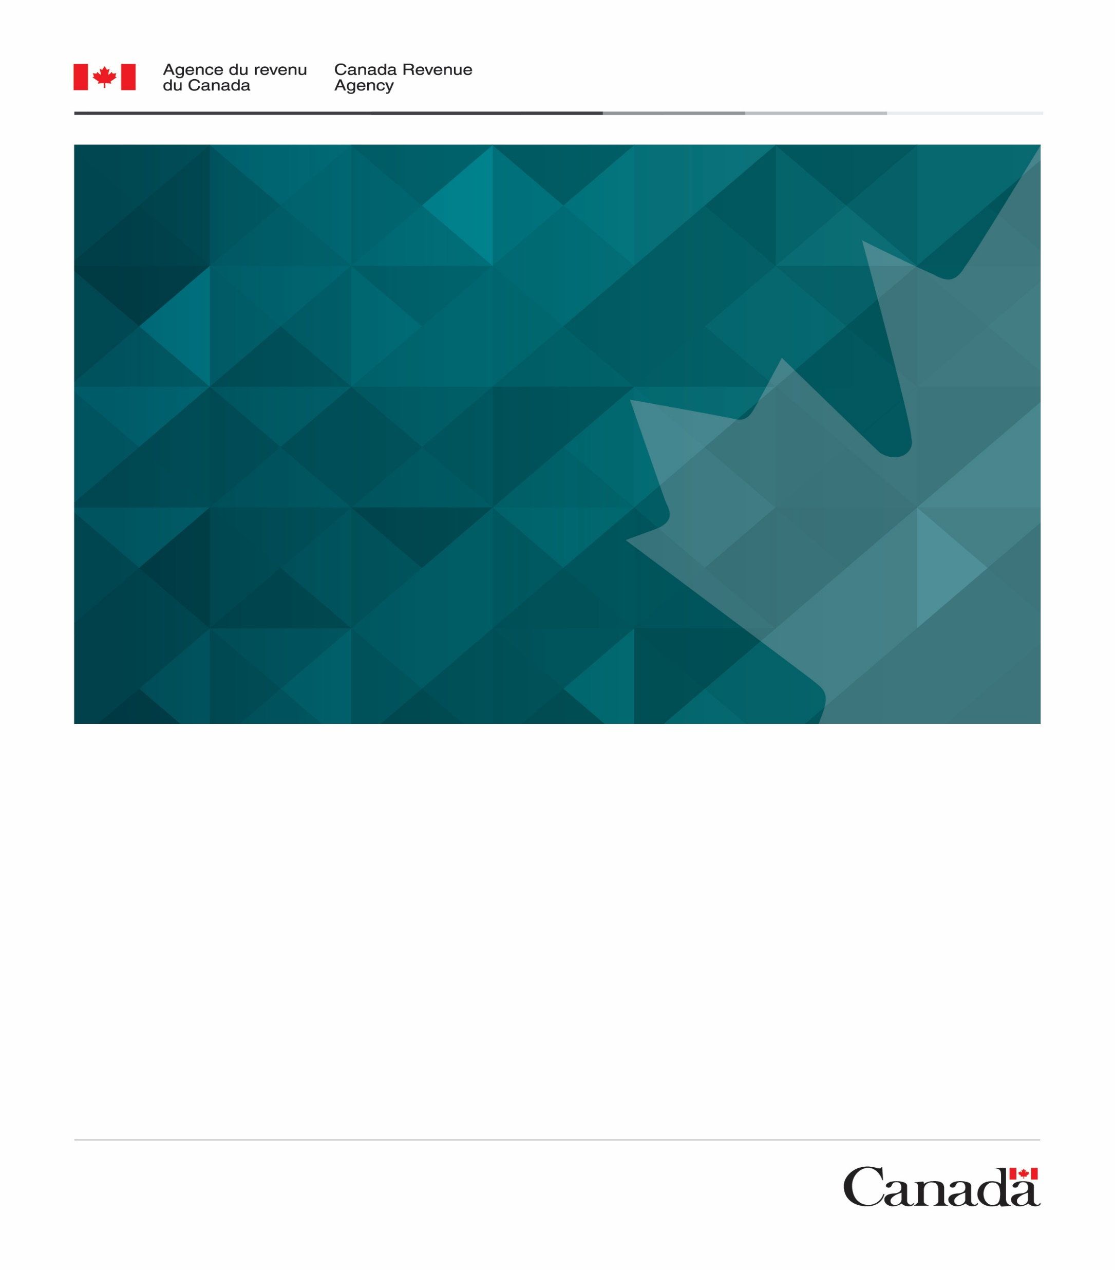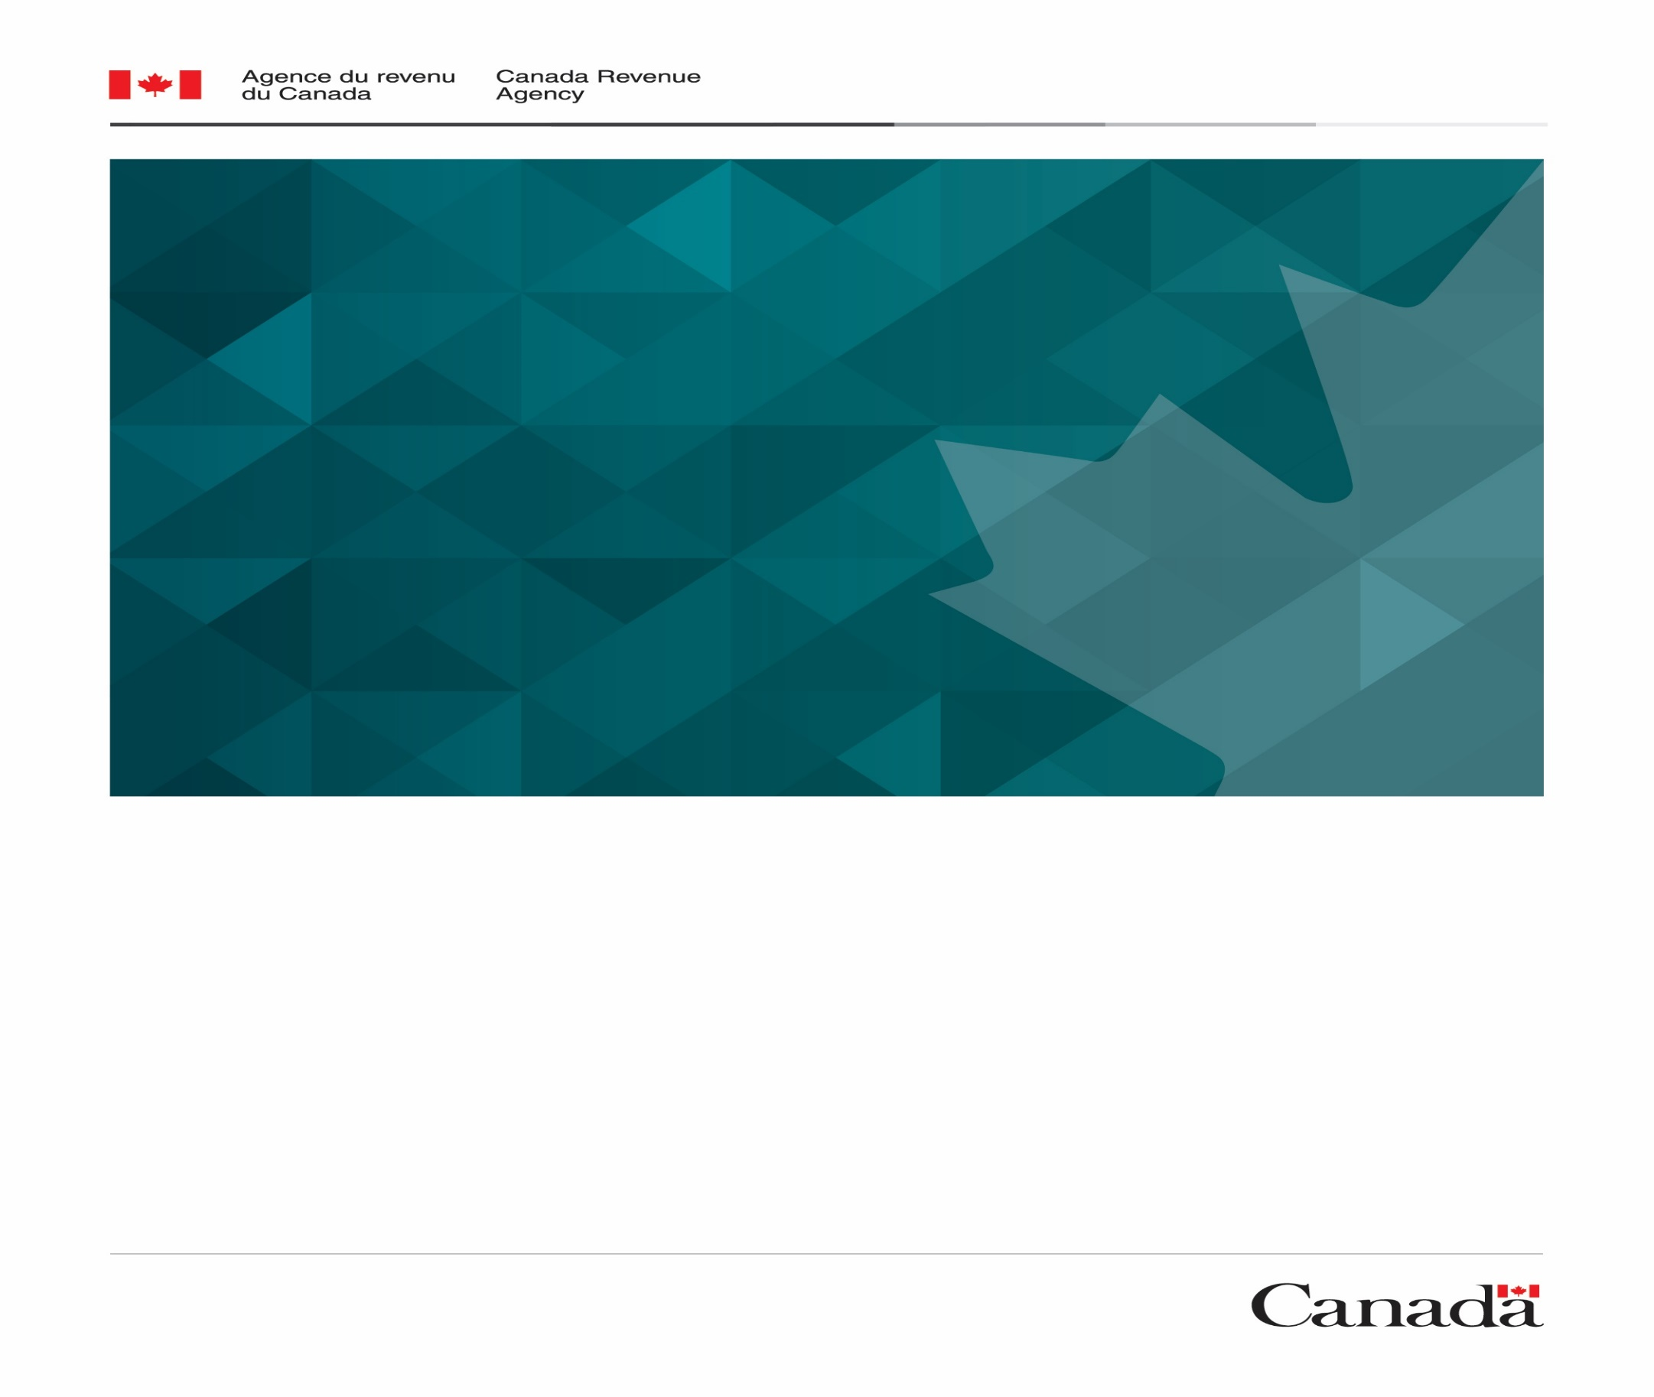

WHEN: Tuesday November 3 @ 1:00 p.m.

WHERE: Microsoft Teams

REGISTER: by emailing us at

[OUTREACHMBG@cra-arc.gc.ca](mailto:OUTREACHMBG@cra-arc.gc.ca%20%20)

Representatives from the Canada Revenue Agency will provide information on:

* The Canada Emergency Response Benefit (CERB)
* The new Canada Recovery Benefit
* The new Canada Recovery Sickness Benefit
* The new Canada Recovery Caregiving Benefit
* Scams

**Please join us for a virtual information session to learn more about the new recovery benefits available to individuals.**

**After CERB: transitioning to new benefits**